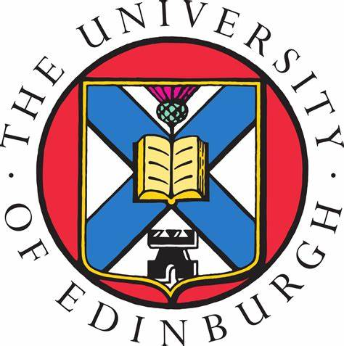 | The University of Edinburgh  College of Medicine and Veterinary Medicine

PReDICTED GRADES REQUEST FORM
Kazakhstan - Nazarbayev Intellectual Schools (NIS) Grade 12
Please complete this form electronically where possible

Name of Applicant:
UCAS Personal ID Number:
School Name & Address:

Subjects  (state whether Standard or Higher Level) |  | Predicted Grades  (A-C)
Subject & Level
Subject & Level
Subject & Level
Subject & Level
Subject & Level
Subject & Level
Subject & Level
Subject & Level
Subject & Level
Subject & Level

Teacher’s Name: | Teacher’s Signature: | Date:

