**Homework: Standard Error and 95% Confidence Intervals**

1. A student measures the running speed of 30 classmates. The mean running speed equals 7.1 mph, with a standard deviation equal to 0.6 mph. How would the student report the mean and standard error for these data?

2. A neuroscience researcher requires a measure of the standard deviation for the rate of neuron firing in mice. However, the researcher cannot find the desired standard deviation in published research papers. Instead, the researcher finds a published article that reports the *standard error* and sample size for a measurement of firing rate. Does this information help the researcher? If so, how?

3. A researcher measured 15 lab mice at birth; the average mass equaled 1.2g with a standard deviation of 0.08g. Calculate a 95% confidence interval (CI) for the mass of mice at birth in this sample.

4. The following three figures (a - c) each display a mean and 95% CI’s for one Control and one Manipulated treatment. Based on the presented means and 95% CI’s, determine whether the Control and Manipulated treatments differ significantly (or whether it is impossible to determine from the information presented) (Elsewhere, we critically assess the concept of “statistical significance”; we include it in this question due to its historical legacy in the scientific literature). *(This question is modified from Whitlock & Schluter’s “The analysis of biological data”.)*

a) The 95% confidence intervals do not overlap between the treatments.

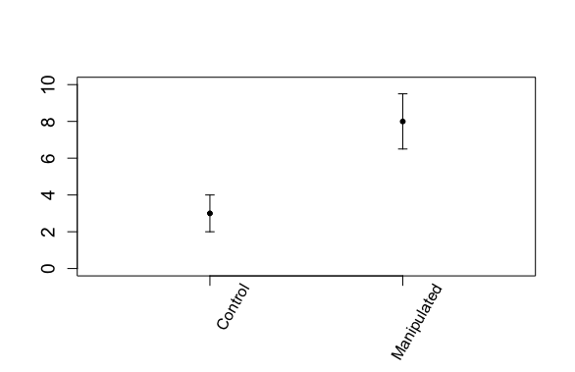

b) The 95% confidence interval for one treatment includes the mean of the other treatment.

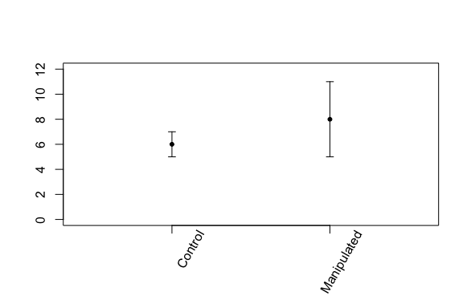

c) The 95% confidence intervals overlap between the two treatments, but the 95% confidence interval for one treatment does not overlap the mean of the other.

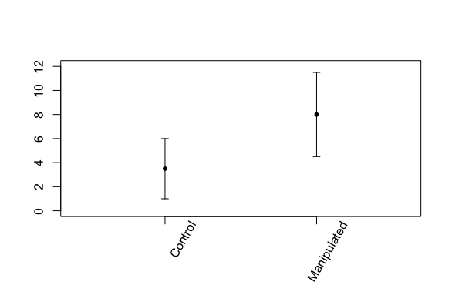

5) The figure, below, comes from a published paper.

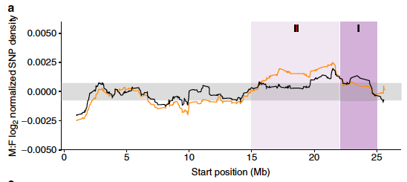

This figure conveys the number of mutations found along the X-chromosome of a fish species; the left end of the figure (Start position 0 Mega-bases (Mb)) represents one end of the X-chromosome and the right end (Start position n ~25 Mb) represents the opposite end; hence the X chromosome is approximately 25Mb long.

The horizontal grey bar centered at zero on the y-axis conveys the 95% confidence interval for the number of mutations found, on average, on autosomes. You will notice two squiggly lines (coloured black and orange) that often occur within the grey region (i.e., the 95% confidence interval for autosomes) but sometimes do not. Roughly speaking, these squiggly black and orange lines convey the numbers of mutations at positions along the X-chromosome for two different populations (one colour for each population).

1. The authors aimed to use this figure to compare the number of mutations along the X-chromosome between the two populations (i.e. between the black and orange squiggly lines). What is missing from this plot that would allow this comparison?
2. By including the horizontal grey region (representing the 95% confidence intervals for mutation numbers on autosomes) the authors invite the readers to compare the number of mutations on the X-chromosome to what’s found on the autosomes. Is this comparison valid, given the available information?